OUTDOOR ATS 40KVA

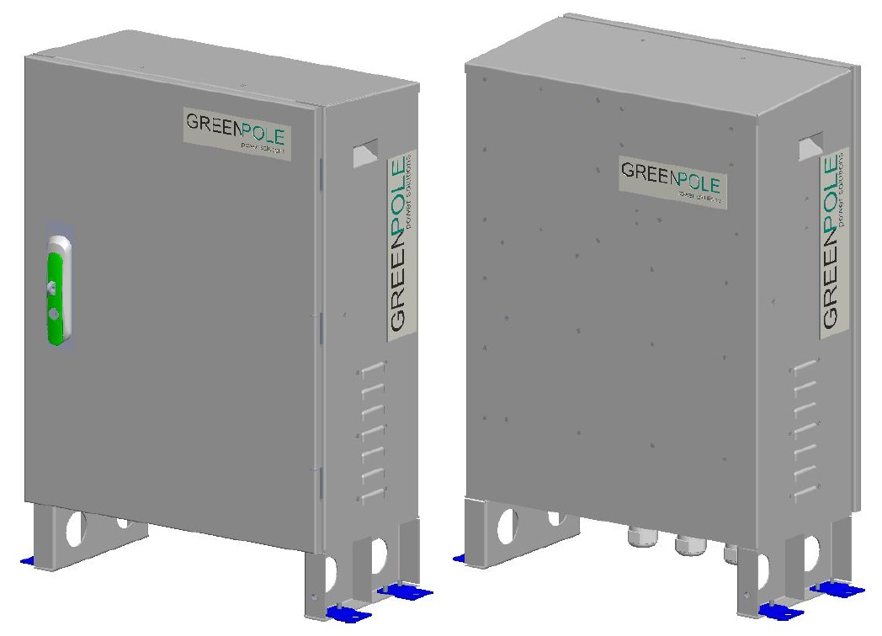
GreenPole power solutions India Pvt Ltd
#5/2, Ground Floor, Baretena Agrahara, Hosur Road
Lavakusha Nagar,Electronic City, Bengaluru – 560100,
Phone: +91-80-48666876
Website: www.greenpole-ps.com
PARTCODE: PMGPPS0175
Version: 1.0
Data: 29-APR-2025
Table of Content

1. Declaration 2

2. Warning Statements and Safety Symbols 2

3. General Safety Precautions 3

4. Electrical Safety 3

5. Delivery 6

6. Technical Support Helpline 6

7. Overall Product Dimension and Grouting Detail 6

8. Transportation, Unloading and Unpacking 7
8.1. Dos and Don’ts 8
8.2. Installation Requirements 8
8.3. Requirements for Cable Routing 9
8.4. System Installation 9

9. System Configuration 11

10. ATS Controller 11
10.1. AMF Controller 11
10.2. Operating modes of AMF Controller 11
10.3. Protection / Supervision Mains 12
10.4. Protection / Supervision DG 12
10.5. Switches Description: 12
10.6. LED Annunciations description: 13
10.7. Setting procedure: 13
10.8. Connection details: 14
10.9. Technical specification: 14
10.10. System Single Line Diagram 15
10.11. Alarms & communication termination details 15
10.12. Default Configuration 15

11. Commissioning of Outdoor ATS 21
11.1. Installation 21
11.2. Inspection Installation 21
11.3. Functional Testing 22

12. Outdoor ATS Maintenance 22
12.1. Routine Maintenance 22
12.2. Circuit Breaker Replacement 24

13. Warranty Exclusion & Recommendation 24
13.1. Conditions or scenarios where the warranty does not apply, such as: 24
13.2. Climatic and Environmental Conditions 24
13.3. Additional Recommendation 25

14. Outdoor ATS I&C Acceptance Report 26

Foreword

Declaration
This document provides the GreenPole Outdoor ATS product introduction, safety and proper handling, Installation and commissioning and system instructions. This product should be used under the specified environment condition specified in this document such as input voltage, operating temperature, and humidity, etc.

Warning Statements and Safety Symbols
DANGER | Indicates the presence of a hazard that will cause death or severe personal injury if the hazard is not avoided.
WARNING | Indicates the presence of a hazard that can cause death or severe personal injury if the hazard is not avoided.
CAUTION | Indicates the presence of a hazard that will or can cause minor personal injury or property damage if the hazard is not avoided.
 | This symbol identifies the need to refer to the equipment instructions for important information
 | These symbols (or equivalent) are used to identify the presence of hazardous ac mains voltage.
 | This symbol is used to identify the presence of hazardous ac or dc voltages. It may also be used to warn of hazardous energy levels.
 | One of these two symbols (or equivalent) may be used to identify the presence of rectifier and battery voltages. The symbol may sometimes be accompanied by some type of statement, for example: “Battery voltage present. Risk of injury due to high current. Avoid contacting conductors with un-insulated metal objects. Follow safety precautions.”
 | One of these two symbols may be used to identify the presence of a hot surface. It may also be accompanied by a statement explaining the hazard. A symbol like this with a lightning bolt through the hand also means that the part is or could be at hazardous voltage levels.
 | This symbol is used to identify the protective safety earth ground for the equipment.
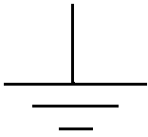 | This symbol is used to identify other bonding points within the equipment.
 | This symbol is used to identify the need for safety glasses and may sometimes be accompanied by some type of statement, for example: “Fuses can cause arcing and sparks. Risk of eye injury. Always wear safety glasses.”
The symbols may sometimes be accompanied by some type of statement, e.g., “Hazardous voltage/energy inside, Risk of injury. This unit must be accessed only by qualified personnel.”

General Safety Precautions
- Ensure that the product is used in environments that meet its design specifications to avoid damaging components and voiding the warranty.
- Ensure that only trained and qualified personnel install, operate, and maintain equipment.
- Comply with local laws and regulations. The safety instructions in this document are only supplements to local laws and regulations.
- Do not operate the device or cables during thunderstorms.
- Remove metal objects such as watches, bracelets, and rings when using the product.
- Use insulated tools on the product.
- Follow specified procedures during installation and maintenance.
- Measure contact point voltage with an electric meter before touching a conductor surface or terminal. Ensure that the contact point has no voltage, or it is within the specified range.
- Note that the load may power off during maintenance or fault location if the power system is not
- Connected to a battery or if battery capacity is insufficient.
- Store cables for at least 24 hours at room temperature before laying out them if they were previously stored at sub-0ºC.
- Routinely check installed equipment and perform maintenance according to the user manual; replace faulty components quickly to ensure that the device works properly.

Electrical Safety
Ground Connection
When installing equipment, protective ground wire must be installed first; when removing the equipment, the protective ground wire must be removed at last. Ensure that equipment is reliably grounded before power on.
High Voltage
 | High voltage potential is present in some parts inside the power system while operational, direct, or indirect contact with these objects through the wet parts will bring fatal danger.  AC power line connection may cause a short-circuit, fire or electric shock accident. AC cable connection and the area wire covered must follow the relevant regulations and design specifications. Peoples, who performed high voltage operations, must have high voltage, AC, and other operations qualifications.
- Obey relevant industry safety standards and design specifications during equipment installation or operation.
- Put up "No Operation" signage on the device or switch can’t be operated during the installation process.
Tools
 | Use special tools instead of common or homemade tools during high voltage and AC operation.
 | Never make DC positive pole and DC negative pole short circuit or non-grounded pole (terminal) shorted to ground in power system during operation.  The power equipment is constant voltage DC power equipment, a short circuit will cause strong electric arc or fire, endangering the safety of persons and equipment.
Short Circuit
- Never wear watches, bracelets, rings, or other conductive accessories when operating.
- Insulated tools must be used when installing and operating.
- Pay attention to the effect on the hot-line work generated by operating space, furnish the insulating protective measures in the operating area to avoid a short circuit dangerous caused by tool stuck or tool fall off when necessary.
 | Non-high voltage, AC jobs in thunderstorms.
Thunderstorm
- The atmosphere will produce a strong electromagnetic field in a thunderstorm. To avoid damage to equipment caused by lightning, you should ensure that the equipment has a good grounding.
 | This product should be placed away from the liquid area, do not install in the vent, air conditioning, machine room outlet window and other prone to water leakage position below, prevent liquid into the equipment caused by short circuit. It is strictly prohibited to put the equipment in flammable, explosive, corrosive gas or smoke environment, and any operation in such environment is strictly prohibited.
Liquid Proof, Explosion Proof
- Do not use water to flush internal and external electrical components of equipment.
- If water, moisture, or condensation is found in the cabinet, please turn off the power immediately. When operating in humid environment, should strictly prevent water and other conductive liquid into the equipment.
 | Before installing, operating, and maintaining batteries, read the instructions provided by the battery vendor. For more safety precautions, see the instructions provided by the battery vendor.
Mechanical Safety
Hoisting Devices
- Only trained and qualified personnel can perform hoisting operations.
- Before hoisting objects, ensure that hoisting tools are firmly fixed onto a weight-bearing object or wall.
- Ensure that the angle formed by two cables is less than 90 degrees.

Using a Ladder
- Use only ladders that are in good condition. Find out and do not exceed the maximum weight capacity.
- The recommended angle for a ladder against another object is 75 degrees. Measure the gradient with a right angle or your arms, as shown in Figure 1-1. Ensure that the wider end of the frame is at the bottom, the base cannot slide, and that the ladder is securely positioned.
Figure 1-1 correct angle for ladders
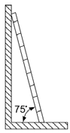

When climbing a ladder:
- Ensure that your body's center of gravity does not shift outside the legs of the ladder.
- To minimize the risk of falling, steady your balance on the ladder before performing any operation.
- Do not climb higher than the fourth rung from the top.
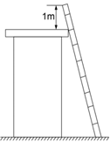
- To climb onto a roof, ensure that the ladder top is at least one meter higher than the roofline, as shown in Figure 1-2.

Moving Heavy Objects
- Be cautious to prevent injury when moving heavy objects.
- Wear protective gloves when moving heavy objects.
Other Considerations:
Acute angle of objects
 | It is strictly prohibited to modify the structure of equipment and change the position of plate parts without authorization. It is strictly forbidden to change components without authorization and drill holes on the cabinet without authorization. Non-compliant changes will affect the heat dissipation of equipment, electromagnetic shielding and other performance, self-drilling will also lead to metal chips into the cabinet resulting in short circuit board.

Object Angle
 | Wear protective gloves when handling equipment or removing the equipment packing case with hands to prevent from being cut.

Delivery
When delivered, inspect the package integrity and the physical conditions of the cabinets carefully.
In case of any damage sustained during transport, immediately inform the carrier, and contact your local Service Center. A detailed report of the damage is necessary for any insurance claim.
 | NOTE!  A DAMAGED CABINET MUST NEVER BE INSTALLED AND COMMISSIONED

Technical Support Helpline
In case of any support in regard of Installation & Commissioning and operation troubleshooting contact following no. and email.
Technical support helpline no’s: | Level-1:
 | Level-2: +91 8095398333
 | e-mail: support@greenpole-ps.com

Overall Product Dimension and Grouting Detail
GreenPole Outdoor ATS modularized design and combined structure. It consists of parts such as ATS controller, DG battery charger & ACDB is mainly used to provide power supply for small and medium-sized station equipment.
System dimensions from all sides and grouting (mounting) details shown in Figure 7.1 to 7.3 Figure
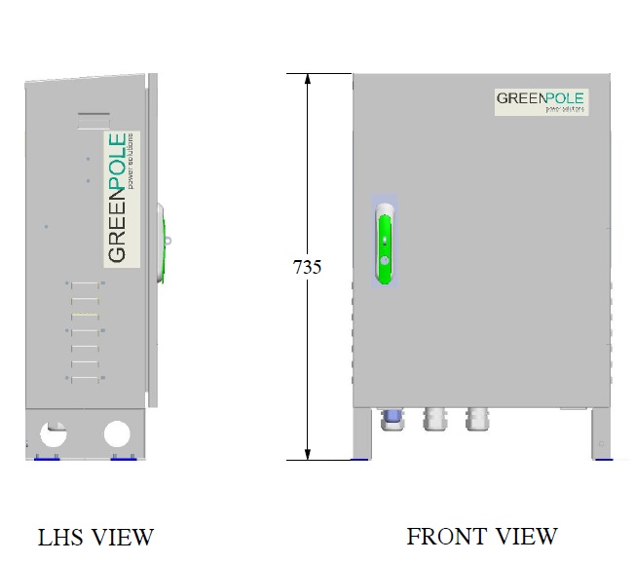

Figure 7.1: External Dimensions of Outdoor ATS

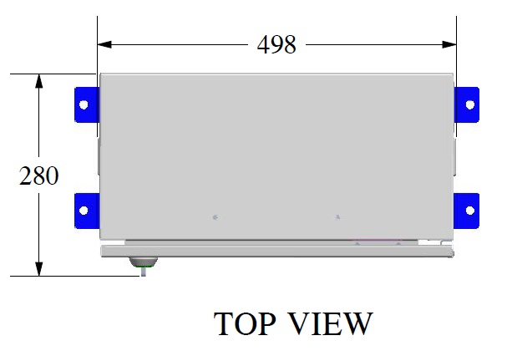

7.2 Mounting Dimension Top view
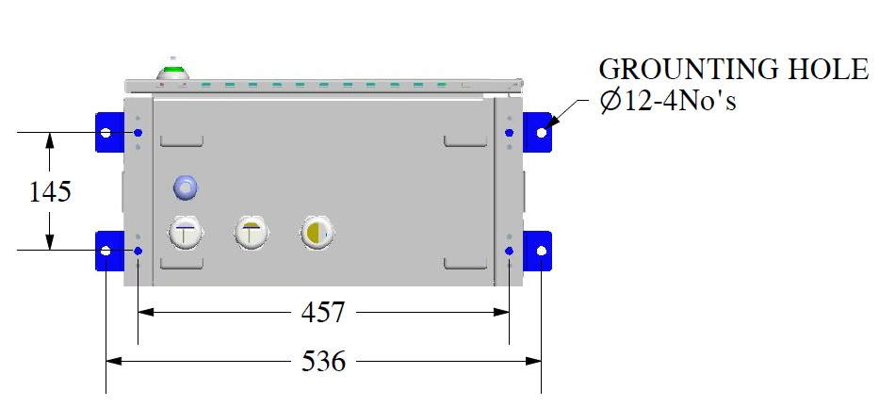

Figure 7.3: Grouting dimensions of Outdoor ATS (Bottom View)

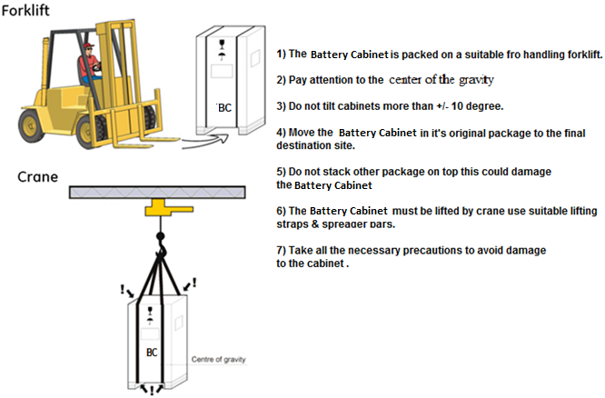
Transportation, Unloading and Unpacking

- The Outdoor ATS cabinet is packed on a suitable pallet to be handled by a forklift or a crane
- Pay attention to the center of gravity
- Move the Outdoor ATS cabinet in its original package until its destination for installation
- Do not stack other packages on top of the cabinet. It could damage it
- The Cabinet should be strapped and buckled during transportation show that it won’t topple or fall from the carrier.
- If the battery cabinet is to be lifted by a crane, use suitable lifting straps and separator bars.
- Take all the necessary precautions to avoid damage to the cabinet for loading and unloading from the carrier.
- Once unloaded position the cabinet on the uniform plinth. Now start unpacking the carton and inspect the cabinet condition if any damaged observed inform the authority to take necessary action. In any case damaged cabinet can be installed at the site.

Dos and Don’ts
Dos | Don’ts
Read and understand this “User Manual” | Do not dismantle the system without authorized service Engineer
Always use Insulated tools only for any field activity and Follow PPE during all site related activity. | Do not place metallic objects on the system.
Follow Installation and commissioning steps as specified in the manual. Make sure of grounding connection first connected while installation and last removed while decommissioning. | Don’t Leave the ground wire open
After I&C completed close & lock the system doors properly & handover the key to customer representative with sign off document duly signed. | Don not Leave equipment exposed to rain or dusty environment by keeping its door open.
DO Keep all connected MCB/MCCB always in ON position | Do not keep unused MCB/MCCB in ON position
Do close wire gutter covers after installation completed | Do not leave open wire gutter covers & cable grommets

Installation Requirements
Construction Personnel Requirements

Only trained and qualified construction personnel are allowed to perform the installation.


Our company will not be liable for the damage to devices or injury to humans caused by failure to follow instructions in this document.
Before installation, pay attention to the following items:
The customer's technical engineers must be trained and be familiar with the proper installation and operational methods. The number of installation personnel varies based on the project progress and the installation environment. Typically, two to four persons are required.

Tools Requirements


Use tools with insulated handles!
Introduction of tools and instrumentation (including, but not limited to, use of the following table tools) required before installation operations are performed.

Table 8.2 Tools and meters
Tools and Meters
  Pallet truck |   Ladder |   Hammer drill & drill bit |   Utility knife |   Heat gun
  Rubber mallet | 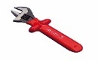  Insulated adjustable wrench |   Multimeter | 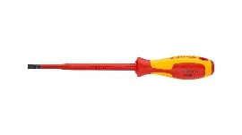  Flat-head screwdriver | Phillips screwdriver  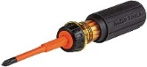
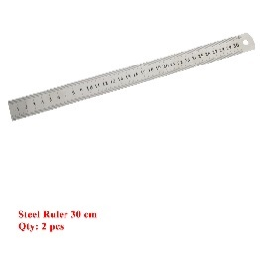  Ruler | 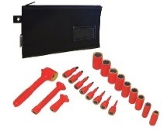  Insulated torque wrench M5 to M12 | Cable tie  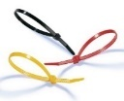 |   Wire nippers |   Insulation gloves
  Polyvinyl chloride  (PVC) insulation tape |   Combination  wrench | Heat shrink tubing   | 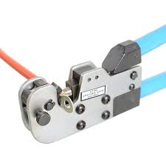  Crimping pliers |   Insulation protective shoes
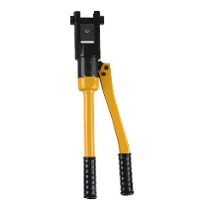  Hydraulic pliers |   Diagonal pliers |   Wire stripper |   Measuring tape | 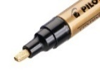  Marker

Requirements for Cable Routing
- Cables should be more than 50mm away from heat sources to prevent insulation layer damage (melting) functional degradation (aging or breakage).
- The bending radius of cables should be at least five times the diameter of the cables.
- Cables of the same type should be bound together. Cables of different types should be a minimum of 30 mm from each other to avoid tangling.
- Cables that are bound together should be close to each other, tidy, and undamaged.
- Ground cables must not be bound to or tangled with signal cables. There should be an appropriate distance between them to minimize interruptions.
- Power cables must be routed straight. No joints or welding should be performed on power cables.
- Use a longer cable if necessary.

System Installation
- When moving equipment by hand, wear protective gloves to prevent cutting of objects
- It is strictly prohibited to modify the structure of equipment and replace the position of plate parts without authorization, to replace components without authorization, and to drill holes on the cabinet without authorization. Non-conforming changes will affect the heat dissipation of equipment, electromagnetic shielding and other performance, self-drilling will also lead to metal chips into the cabinet, resulting in circuit board short circuit
- According to the specific situation of the site, select the rack placement position, the placement is based on the principle of considering the reasonable inlet and outlet lines of the equipment, leaving no less than 1m space between the front, back, right and left and the wall and other obstacles, and the installation height should be convenient for observation, monitoring and display, while considering the convenience of ventilation, heat dissipation and operation and maintenance, the frame shall be installed horizontally, and the inclination between the cabinet and the horizontal shall not exceed 5°, and shall be fixed on the frame or the floor with bolts, installation procedures of the sub rack are as follows：

Details of inner structure of power system refer below picture：8.4.1 & 8.4.2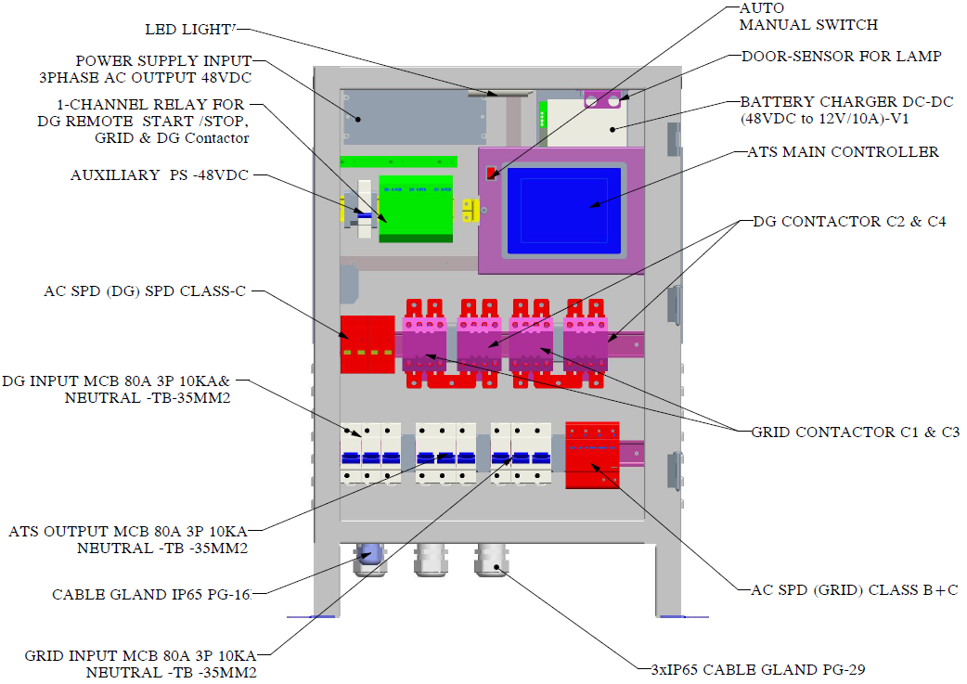

Figure 8.4.1: Internal components view

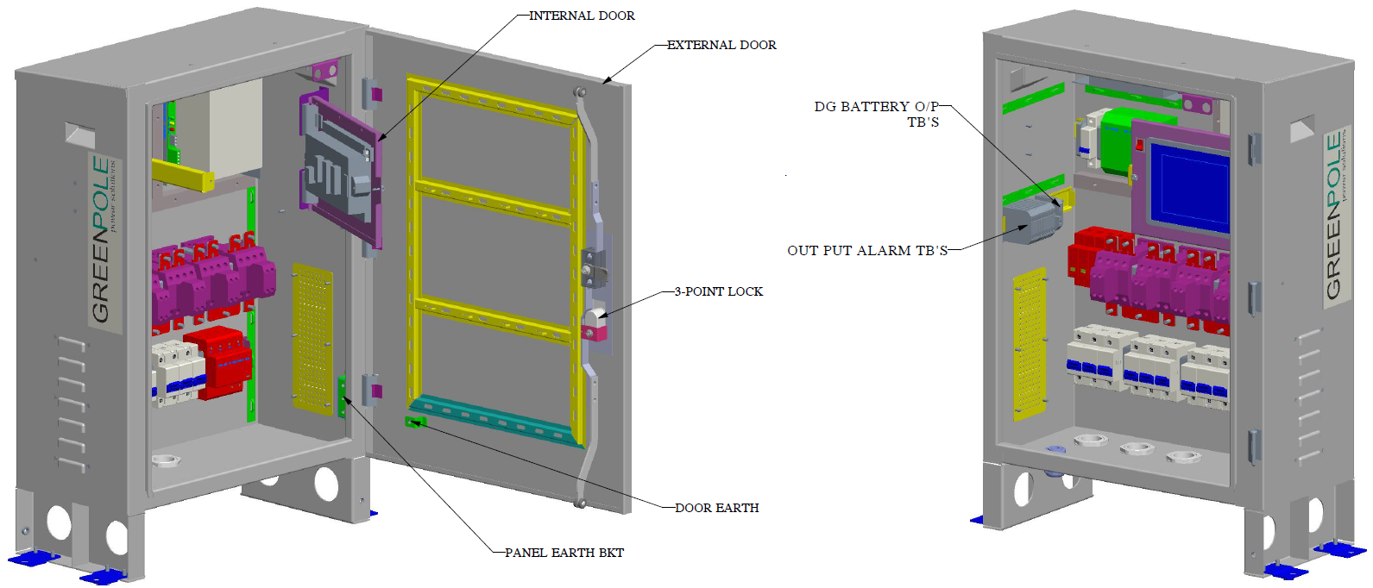
Figure 8.4.2 Internal Components View

System Configuration
ITEM | CONFIGURATION
Grid Input | MCB 1*80A 3P + 1*25 SQMM TB
DG Input | MCB 1*80A 3P + 1*25 SQMM TB
ATS Output | MCB 1*80A 3P + 1*25 SQMM TB
SPD | Class B+C for Grid & Class C for DG
Auxiliary control | MCB 1*6A SP + 1*10SQMM TB
Alarm TB | 10*2.5 SQMM TB
GRID INPUT CABLE RATING | 16SQmm 4core is recommended, the wires of Lines and N are red, Yellow, Blue & black respectively.
DG INPUT CABLE RATING | 16SQmm 4core is recommended, the wires of Lines and N are red, Yellow, Blue & black respectively.
SYSTEM GROUNDING | 16SQmm Green

ATS Controller
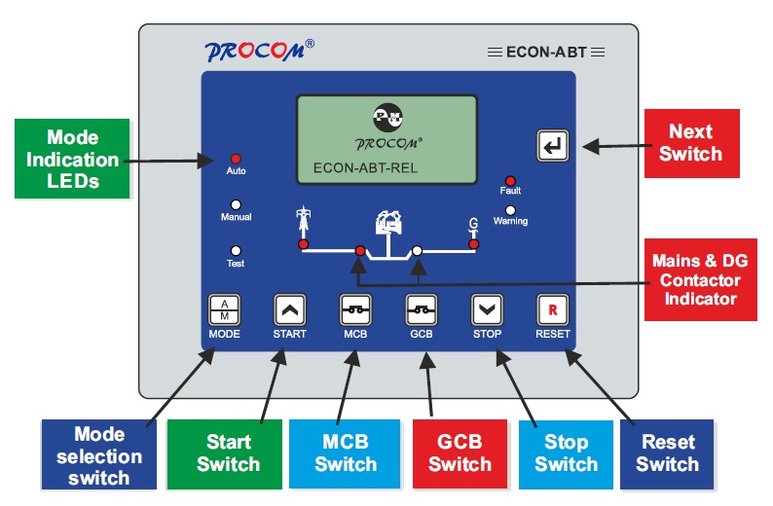
ECON is a universal controller for DG Set which can be configured as either automatic or manual controller.

AMF Controller
- Three Phase Mains Three Phase DG

Operating modes of AMF Controller
- Manual Mode
- Auto Mode
This mode can be selected by operating through Auto/Manual switch.
- Teat mode
This mode can be selected by pressing the mode switch while unit in auto mode

Protection / Supervision Mains
- Under/Over Voltage
- Under/Over Frequency
- Phase Sequence
- Voltage Unbalance

Protection / Supervision DG
- under/Over Voltage
- Under/Over Speed
- Service Due
- Fail To Start (only when configured as AMF controllers)
- Fail To Stop (only when configured as AMF controllers)
- Fault Data Recording: Last 64 fault with date and time stamping
- Event Recording: Last 64 event with date and time stamping
- Password Protection: Three-digit password protection for system settings.
- Real Time Clock (RTC)
- Communication: USB, Fully Isolated RS485

Switches Description:
ECON has 7 switches provided on its front panel. The table below describes the operation of these.

Switch Symbol | Switch Function | Description
 | Next | Normal operation mode: In this mode, it is used to change the parameters being displayed on LCD. Programming Mode: Next key is used to select the next parameter to be programmed.
 | Increment  /Start | This key has dual function  Programming Mode: It is used to increment  the value of the parameters under programming. Manual mode: it is used to issue the crank/ start command to DG
 | Decrement  /Stop | This key has dual function  Programming mode: It is used to decrement the value of the parameter under programming.  Manual mode: It is used to issue the stop command to DG
 | Reset | Reset key resets the Hooter and Fault signals. The first press shall reset the hooter and next shall  reset the faults. A long press of 1 Sec shall reset both.
   | Programming  /History Fault Mode Entry | If both the keys are pressed simultaneously the unit will enter in Programming Mode History Fault/Service Hours
 | MCB | In Manual Mode this toggles the mains contactor, On/Off
 | GCB | In Manual Mode this toggles the generator contactor, On/Off
 | MODE | Toggle between Auto & Test Mode

LED Annunciations description:
ECON has nine annunciations on its front panel. These either announce the faults or indicate the status of the system.
Nomenclature | Symbol | Description
Auto |  | Led lights up when ECON is in Auto mode
Manual Mode |  | Led lights up when ECON is in manual mode
Test Mode |  | Led lights up when ECON is in Test Mode
Mains Voltage |  | This symbol lights up continuously if Main is healthy else starts blinking.
MCB |  | LED turns on in case the mains breaker is switched on or else turned off  In manual mode, this LED is switched on by feedback from mains contact on pin 29
GCB |  | LED turns on in case the DG breaker is switched on or else turned off  In manual mode, this LED is switched on by feedback from DG contact on pin 28
DG Voltage |  | This indication glows continuously when the generator is running.
Warning | Warning | This LED blinks in case of a warning.
Fault | Fault | This LED blinks in case of a fault
Please note: Operating Mode cannot be changed if the unit has stopped in a faulty condition, or the engine is cranking.
Auto, Manual and Test is Radio buttons and only one can be active at a time.
Do not enter manual mode while test mode is operating. Firstly, enter in auto mode then manual mode.

Setting procedure:
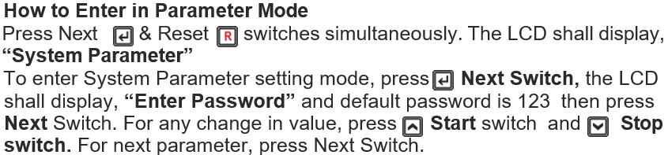

Connection details:
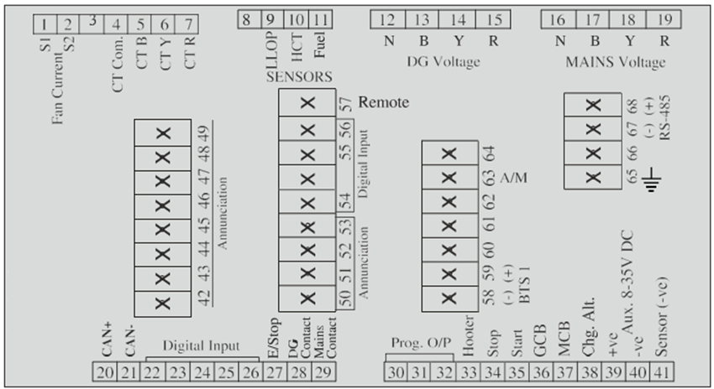

Technical specification:
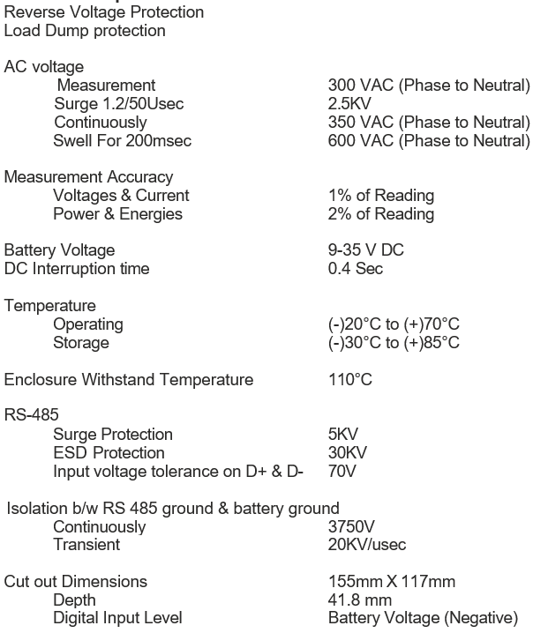

System Single Line Diagram
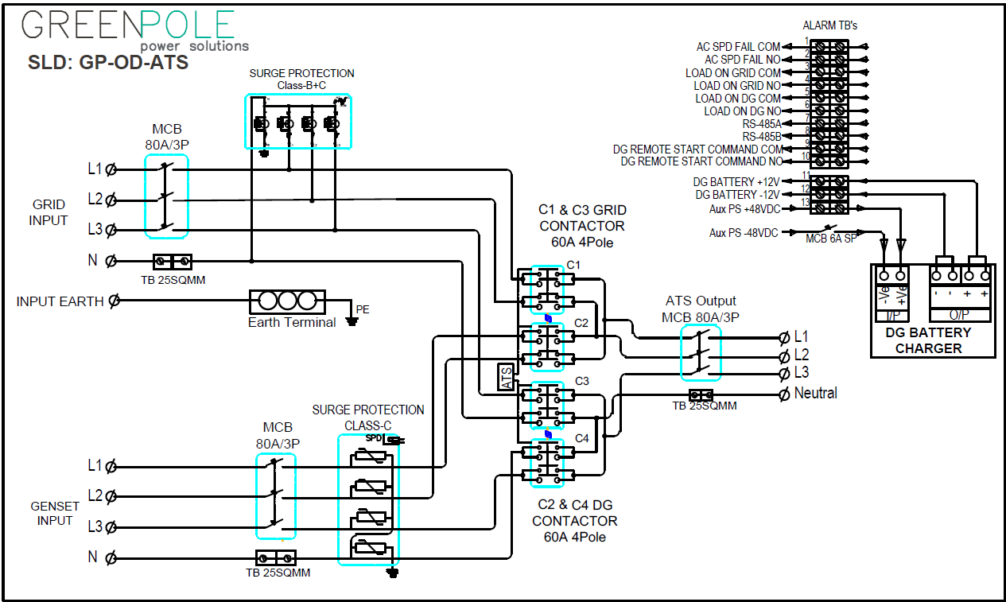

Alarms & communication termination details
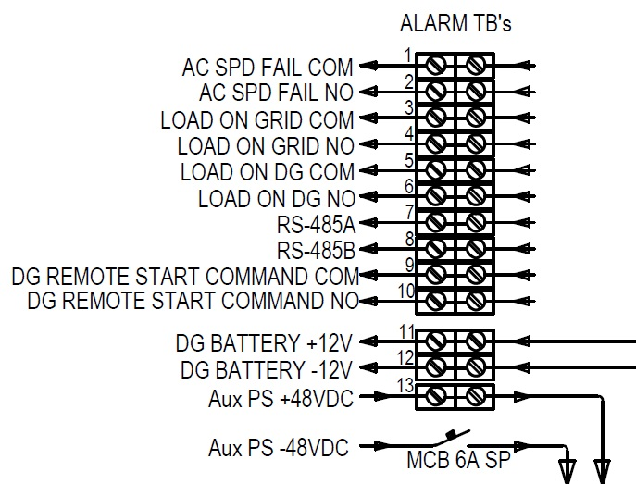

Default Configuration
Sl.No. | Parameter | Default Value
System Supply
1 | Supplier | TMTL
2 | System Configuration | AMF-M:3p/G:3p
3 | Solenoid Type | Pull to Start
4 | J1939 Address | Disable
5 | LLOP Sensor | Disabled
6 | User LLOP R1 | 10 ohm
7 | User LLOP V1 | 0 bar
8 | User LLOP R2 | 29 ohm
9 | User LLOP V2 | 1 bar
10 | User LLOP R3 | 38 ohm
11 | User LLOP V3 | 1.5 bar
12 | User LLOP R4 | 48 ohm
13 | User LLOP V4 | 2 bar
14 | User LLOP R5 | 57 ohm
15 | User LLOP V5 | 2.5 bar
16 | User LLOP R6 | 67 ohm
17 | User LLOP V6 | 3 bar
18 | User LLOP R7 | 86 ohm
19 | User LLOP V7 | 4 bar
20 | User LLOP R8 | 105 ohm
21 | User LLOP V8 | 5 bar
22 | User LLOP R9 | 124 ohm
23 | User LLOP V9 | 6 bar
24 | User LLOP R10 | 143 ohm
25 | User LLOP V10 | 7 bar
26 | Fuel Sensor | Disabled
27 | User Fuel R1 | 10 ohm
28 | User Fuel V1 | 0
29 | User Fuel R2 | 29 ohm
30 | User Fuel V2 | 0.1
31 | User Fuel R3 | 48 ohm
32 | User Fuel V3 | 0.2
33 | User Fuel R4 | 67 ohm
34 | User Fuel V4 | 0.3
35 | User Fuel R5 | 86 ohm
36 | User Fuel V5 | 0.4
37 | User Fuel R6 | 105 ohm
38 | User Fuel V6 | 0.5
39 | User Fuel R7 | 124 ohm
40 | User Fuel V7 | 0.6
41 | User Fuel R8 | 143 ohm
42 | User Fuel V8 | 0.7
43 | User Fuel R9 | 181 ohm
44 | User Fuel V9 | 0.9
45 | User Fuel R10 | 200 ohm
46 | User Fuel V10 | 1
47 | Fuel Tank Cap | Disable
48 | HET Sensor | Disabled
49 | User HET R1 | 540 ohm
50 | User HET V1 | 40 Celsius
51 | User HET R2 | 458 ohm
52 | User HET V2 | 45 Celsius
53 | User HET R3 | 222 ohm
54 | User HET V3 | 65 Celsius
55 | User HET R4 | 120 ohm
56 | User HET V4 | 85 Celsius
57 | User HET R5 | 93 ohm
58 | User HET V5 | 90 Celsius
59 | User HET R6 | 80 ohm
60 | User HET V6 | 95 Celsius
61 | User HET R7 | 70 ohm
62 | User HET V7 | 100 Celsius
63 | User HET R8 | 60 ohm
64 | User HET V8 | 105 Celsius
65 | User HET R9 | 53 ohm
66 | User HET V9 | 110 Celsius
67 | User HET R10 | 46 ohm
68 | User HET V10 | 115 Celsius
69 | Sensor Open | Disable
70 | CT Ratio | 20 Ratio
71 | Generator RPM | 1500
72 | Contact Pin 32 | None
73 | Contact Pin 31 | None
74 | Contact Pin 30 | None
75 | Over Load KW | 32.0 KW
76 | Over Current | 60.0 Amps
77 | Over Load Delay | 10 Sec
78 | High Load KW | Disable
79 | High Load Delay | 3600 Sec
80 | D Input 1 | RWL
81 | D Input Plarity 1 | Normal Open
82 | D Input 2 | MAINS MCCB
83 | D Input Plarity 2 | Normal Open
84 | D Input 3 | FUEL
85 | D Input Plarity 3 | Normal Open
86 | D Input 4 | HET
87 | D Input Plarity 4 | Normal Open
88 | D Input 5 | C Door Open
89 | D Input Plarity 5 | Normal Open
90 | D Input 6 | Mains Charger
91 | D Input Plarity 6 | Normal Open
92 | D Input 7 | DG MCCB
93 | D Input Plarity 7 | Normal Open
94 | D Input 8 | Canopy Temp
95 | D Input Plarity 8 | Normal Open
96 | D Input 9 | Remote Start
97 | D Input Plarity 9 | Normal Open
98 | MCB Plarity | Normal Open
99 | Fan High Current | Disable
100 | Mode Change Hr | Disable
101 | Mode Change Warn | 120 Sec
102 | Mode Change | Selector Switch
Generator Supply
103 | Generator Over Volt | 255 V
104 | Generator Under Volt | 185 V
105 | Generator Volt Delay | 15 Sec
106 | Generator Over Freq. | 55.0 Hz
107 | Generator Under Freq. | 45.0 Hz
108 | Generator Freq. Delay | 5 Sec
109 | Current Unbalance IN | Disable
110 | Pick Up Voltage | 30 V
111 | Pick Up RPM | 300 RPM
112 | Service Due Hour | 999 Hrs
113 | Crank Cut Method | Volt ,Freq
AMF / Main Supply
114 | Main Over Voltage Trip | 280 V
115 | Main Over Voltage Return | 275 V
116 | Main Under Voltage Trip | 145 V
117 | Main Under Voltage Return | 165 V
118 | Mains Volt Delay | 10 Sec
119 | Mains Over Frequency | 55.0 Hz
120 | Mains Under Frequency | 45.0 Hz
121 | Mains Frequency Delay | 5 Sec
122 | Mains Restor Time | 30 Sec
123 | WarmUp Time | 10 Sec
124 | Gen Start Delay | 0 Mins
125 | Gen On Time | 210 Mins
126 | Gen Rest Time | 10 Mins
127 | Mains Over Load | Disable
128 | Contactor Protection | Enabled
129 | Mains Fail | All Phases Fail
130 | GCB To MCB Delay | 5 Sec
131 | Recooling Time | 60 Sec
132 | Service Delay Hrs | Disable
133 | Service Run Min | 1 Mins
Protection List
134 | Fuel Warn Level | 0.5
135 | Fuel Warn Delay | 10 Sec
136 | Fuel Trip Level | 0.15
137 | Fuel Trip Delay | 10 Sec
138 | LLOP Trip Level | 0.7 Kg/cm2
139 | LLOP Trip Delay | 10 Sec
140 | HET Trip Level | Disable
141 | D. Input 1 Delay | 10 Sec
142 | D. Input 2 Delay | 10 Sec
143 | D. Input 3 Delay | 10 Sec
144 | D. Input 4 Delay | 10 Sec
145 | D. Input 5 Delay | 10 Sec
146 | D. Input 6 Delay | 180 Sec
147 | D. Input 7 Delay | 10 Sec
148 | D. Input 8 Delay | 10 Sec
149 | D. Input 9 Delay | 1 Sec
150 | CHG Alternator | Disable
151 | Hooter On Time | 30 Sec
152 | Crank OnTime | 5.0 Sec
153 | Crank Gap Time | 10 Sec
154 | Crank Attempts | 3
155 | Solenoid On Time | 30 Sec
156 | Auto Scroll On/Off | OFF
157 | Battery/Supercapacitor UV Warn | 10.0 V
158 | Battery/Supercapacitor OV Warn | 14.5 V
159 | Remote on | Disable
160 | NESA Dis/Enab | Disable
161 | NESA OFF Time | 23:59 Hr:Min
162 | NESA ON Time | 23:59 Hr:Min
163 | NCD Strategy | Disable
164 | NCD Warn Hrs | 36
165 | NCD Fault Hrs | 72
166 | NCD Heal Hrs | 40
BTS
167 | BTS Under Voltage | 47.5 V
168 | BTS Voltage Delay | 20 Sec
Annuciation
169 | Ann Mains OK | No Annunciation
170 | Ann Mains NOK | No Annunciation
171 | Ann DG ON | No Annunciation
172 | Ann DG OFF | No Annunciation
173 | Ann Fuel Trip | No Annunciation
174 | Ann LLOP Trip | No Annunciation
175 | Ann HET Trip | No Annunciation
176 | Ann DG VOL | No Annunciation
177 | Ann Emergency | No Annunciation
178 | Ann DG O/L | No Annunciation
179 | Ann DG Freq | No Annunciation
180 | Ann RWL Fault | No Annunciation
181 | Ann Chg/VBelt | No Annunciation
182 | Ann Fail Start | No Annunciation
183 | Ann Fail Stop | No Annunciation
184 | Ann Current Unbalance | No Annunciation
185 | Ann Fuel Open | No Annunciation
186 | Ann LLOP Open | No Annunciation
187 | Ann HET Open | No Annunciation
188 | Ann Cannopy | No Annunciation
189 | Ann Fire | No Annunciation
190 | Ann Oil Temp | No Annunciation
191 | Ann Oil Level | No Annunciation
192 | Ann Mains O/L | No Annunciation
193 | Ann Service Due | No Annunciation
194 | Ann Batt/Supercapacitor NOK | No Annunciation
195 | Ann BTS 1 NOK | No Annunciation
196 | Ann Reserved | No Annunciation
197 | Any Common Fault | No Annunciation
198 | Half Fuel | No Annunciation
199 | C Door Open | No Annunciation
200 | Ann DG in Manual | No Annunciation
201 | Ann DG Not in Manual | No Annunciation
202 | Ann Unit Ok | No Annunciation
203 | Ann Mode Change Warn | No Annunciation
204 | Ann CPCB4+ Audio | No Annunciation
205 | Ann J1939 1 | No Annunciation
206 | Ann J1939 2 | No Annunciation
207 | Ann J1939 3 | No Annunciation
208 | Ann J1939 4 | No Annunciation
209 | Ann EGR Warn | No Annunciation
210 | Ann NCD Warn | No Annunciation
211 | Ann NCD Fault | No Annunciation
Device Communication Setting
212 | Device ID | 34
213 | Baud Rate | 9600
214 | Device Parity | NONE
215 | Stop Bits | One

Commissioning of Outdoor ATS

Installation
Check that all input and output circuit breakers or fuses are in off state. All input and output connection cables, signal wires, working ground wires and protective ground wires are firmly connected.
Check box and earthing grounding resistance is not higher than 0.1 Ω between components.
Refer the SLD and perform connection as per below sequence.
Install Earth/ Ground cable
Step 1: Insert the Earth/Ground cable through the hole on the right side of the Cable entrance through the cable gland and tight it.
Install AC input cable (Grid and DG)
- Make sure the front AC input is left open to an OFF state and place a prominent "do not operate" sign.
- Put all MCB OFF before installing the cable.
Step 1: Connect the 220AC Ph-Neu 2-wire Grid AC input cable through the cable entry bottom
Step 2: Fastening the AC input line to the corresponding AC input terminal.
Step 3: Connect the 220AC Ph-Neu 2-wire DG AC input cable through the cable entry bottom
Step 4: Fastening the DG input line to the corresponding AC input terminal.

Inspection Installation
- Check hardware installation
  - Check that all screws are properly fastened (especially those used for electrical connections) and that the flat washer and spring washer are properly installed.
  - Check that the rectifier module is fully inserted into each slot and locked correctly.
- Check electrical connection
  - Check that all MCB are OFF.
  - Check that the flat washer and spring washer are securely installed on all the terminals, and that all OT terminals are complete and correctly connected.
  - Check whether the battery is properly installed and whether the battery cable is properly connected.
  - Check that the input and output power cables and ground cables are properly connected.
- Check the cable installation
  - Check the cable installation
  - Check that all cables are lined up neatly and tightly connected to their nearest cables, without twisting or overly bending.
  - Check cable label is correct, firm, and consistent.

Functional Testing
Auto mode:
- Check all cables are connected properly, tighten properly & no short in between Line & Neutral or Line to Earth.
- Check the Input supply voltage is within the range and polarity (Line & neutral)
- Connect auxiliary power supply 48VDC from HPS
- Switch on Aux MCB and verify ATS controller power on
- Keep all output MCB’s in OFF position & switch ON the Grid Input MCB and verify the contactor function and then check voltage at all output MCB/MCCB.
- After confirming Grid operation, switch OFF the Grid input MCB and verify system ON battery mode. If BTS voltage is <47.5V check DG crank and then switch ON DG input MCB and verify the contactor function and check the output voltage.
- Switch on the output MCB/MCCB and check the voltage at end termination is healthy.
Manual mode:
- The engine must be started manually by manually pressing “Start” switch or start at DG end manually.
- Switch ON the DG input MCB and Press the GCB button in ATS controller & verify the DG contactor is ON and ensure output voltage
- To stop the generator, switch OFF the GCB contactor by pressing GCB and press “STOP” switch
- Switch ON the Grid input in Manual mode. Press the MCB button in ATS controller and verify the Grid (C1 & C3) contactor is ON and ensure output voltage.

Outdoor ATS Maintenance

Routine Maintenance
Routine maintenance is to find out the potential causes of failure in time before the failure of the equipment affects the business and to carry out effective maintenance. Processing to avoid business impact. Maintenance engineers must be familiar with relevant site conditions before maintenance and be prepared with maintenance tools in advance. The system can work continuously and uninterruptedly. In order to ensure the reliability of power supply, it is necessary to do a good job in daily maintenance to make the power supply system work in the best state.
- Regular cleaning of the system (Air filters, door gasket and cable entry & exit) to prevent dust accumulation and other phenomena every week or 15 days once. (Based on the site environmental condition)
- Check the parameters of the power system once a week if they are normal. If there are abnormalities, they should be eliminated in time.
- Every month or after the thunderstorm should check whether the lightning protector is invalid, if it is invalid, it should be replaced in time.
- Check the MCB/MCCB status once a month, check the connection of input and output wiring loosening and bad contact once a month.
- Check every month whether the input and output conductors are intact and intact. If there is any damage, they should be replaced in time. Check every circuit breaker once a half year whether it can switch flexibly, whether it burns or not.
- Maintenance and maintenance of batteries shall be carried out in accordance with the relevant instructions of batteries.
Table 12.1.1 List of Periodic Maintenance
Maintenance items | Maintenance content
 | Checkpoints | Inspection methods | processing method
Appearance of cabinet | No damage to locks of cabinet doors | Visual inspection, switch door lock | Lock changing
 | Cabinet damaged and deformed | Visual inspection | If the damage is serious, the cabinet should be replaced.
 | Is there corrosion and rust in cabinet | Visual inspection | Re-painting after rust removal
 | Does the cabinet have dust, oil and other covering | Visual inspection | Clean with soft cotton cloth
Dustproof net | Are there any ash deposits | Visual inspection | Clean up
Temperature in cabinet | Is it too high or too low | Thermometer measurement | Take reasonable heating or cooling measures.
system output | Is Voltage Output Normal | A multimeter | Refer to Fault Analysis and Handling
indicator | if the indicator is normal | Visual measurement | Refer to Fault Analysis and Handling
Wireway | Whether the insulating layer and terminal are damaged or not | Visual measurement | Replacement of cables or insulated terminals

Circuit Breaker Replacement
Preparation in advance
- Prepare tools and materials: anti-static wristband/anti-static gloves, cross screwdriver, one-word screwdriver, anti-static box/anti-static bag, cabinet door key.
 the front power source must be disconnected before the circuit breaker is replaced.
Operational steps
- Wear anti-static wristband or gloves. And disconnect the power source of the front stage.
- Remove the cables/busbars on the circuit breaker in turn with cross/star type screwdrivers. Insulate the cables in time and label them in the process of disassembly.
- Use a screwdriver unscrew mounting hardware’s, and then remove the circuit breaker.
- After replacing circuit braker connect back wires/busbars back to original position

Warranty Exclusion & Recommendation

Conditions or scenarios where the warranty does not apply, such as:
- Improper handling, transportation, installation, use or maintenance.
- Damage due to accidents, natural disasters or environmental conditions (Flod, Earth quack, Fire, High wind etc.) outside the specific/product range.
- Unauthorized repairs or modifications, addition of external equipment and tempering cases.
- Abnormal input to the system and related product.
- Costs that may be incurred by the customer, such as shipping or handling fees or special request to support.

Climatic and Environmental Conditions
Dust and Particulate Matter:
- Adopt proper and routing maintenance for dust and particulate levels in the operating environment.
- Necessity of filters, enclosures, Rack & Rectifier cleaning to protect the Power system and related product
Recommendations:
- Regular Maintenance-Weekly basis to ensure optimal performance and longevity.

Corrosive Environments:
- Restrictions on operating the Power System in corrosive environments.
- Recommend protective measures or coatings if necessary.
Recommendations:
- Regular Maintenance-Weekly basis to ensure optimal performance and longevity.
Electrical Environment:
- Requirements for input voltage, frequency, and power quality must be as specified on product and manual.
- Surge protection and grounding maintained as recommended.
Operating Temperature Range:
- Minimum and maximum operating temperatures must be as specified (e.g., 0°C to 50°C).
- Temperature-related conditions that could affect warranty coverage.
Altitude:
- Maximum operating altitude must be withing range (e.g., up to 2000 meters above sea level).

Additional Recommendation
Record Keeping:
Keeping detailed records of installation, maintenance, and any issues encountered to support potential warranty claims.

Outdoor ATS I&C Acceptance Report
ATS CHECK LIST
CUSTOMER: |  | Site In charge Name & Nun:
SITE NAME/CODE: |  | Installation Date:
Commissioning Date: |  | System Sr No:
I&C Eng. Name: |  | Contact No:
VISUAL INSPECTION/OBSERVATIONS
SL.NO | PARAMETER | OBSERVATION STATUS |  | REMARKS
1 | MOUNTING OF RACK/SUB RACK MECHANICAL NUTS / BOLTS | Ok | Not Ok
2 | TIGHTNESS OF ELECTRICAL TERMINATION | Ok | Not Ok
3 | LUGGING & CRIMPING OF INSTALLATION CABLES | Ok | Not Ok
4 | FIXING OF NUTS & BOLTS AT MOUNTING HOLES | Ok | Not Ok
5 | POWER & CONTROL CABLE ROUTING | Ok | Not Ok
6 | TERMINATION OF LOAD MCB/MCCB | Ok | Not Ok
7 | FIXING OF CABLE GLANDS/GROMMET | Ok | Not Ok
8 | DOOR LOCK OPERATION | Ok | Not Ok
FUNCTIONAL VERIFICATION
1 | ATS MANAUL / AUTO MODE | Ok | Not Ok
2 | DG START & STOP IN MANUAL MODE | Ok | Not Ok
3 | GRID & DG CONTACTOR OPERATION IN MANUAL MODE | Ok | Not Ok
4 | GRID & DG CONTACTOR OPERATION IN AUTO MODE | Ok | Not Ok
5 | DG REMOTE START SIGNAL IN AUTO MODE | Ok | Not Ok
6 | GRID & DG CONTACTOR FEEDBACK | Ok | Not Ok
7 | DG BATTERY CHARGER OPERATION | Ok | Not Ok
8 | AC-DC CARD OPERATION | Ok | Not Ok
9 | GRID INPUT & DG INPUT VOLTAGE SENSING | Ok | Not Ok
10 | ATS OUTPUT VOLTAGE at ALL OUTPUT POINTS | Ok | Not Ok
11 | SPD FAIL ALARM | Ok | Not Ok
12 | BTS & DG BATTERY VOLTAGE SENSING | Ok | Not Ok
13 | DG START FOR BTS BATTERY VOLTAGE LOW | Ok | Not Ok
14 | ATS CONTROLLER RS485 COMMUNICATION | Ok | Not Ok
GREENPOLE POWER SOLUTIONS |  | CUSTOMER
NAME: |  | NAME:
DESIGNATION: |  | DESIGNATION:
CONTACT NO: |  | CONTACT NO:
DATE: |  | DATE:
SIGNATURE: |  | SIGNATURE:

